Cloud Deployment: Zeus Planetary Monitor
Platform: Microsoft Azure
Architecture: Static Web Hosting, DNS, Key Vault & Monitoring
1. Project Overview
Zeus Planetary Monitor is a web app that tracks live earthquakes, tsunamis, cyclones, and volcanoes using data from USGS and NASA. To make the project production-ready, it was deployed on Microsoft Azure using automated CI/CD pipelines and enterprise cloud services.
2. Azure Resources Used
A. Azure Static Web Apps (Hosting & CI/CD)
- Hosts the HTML, CSS, and JavaScript frontend on Azure's global network.
- Automatically builds and deploys updates whenever code is pushed to the GitHub repository.
- Provides free SSL/HTTPS security out of the box.
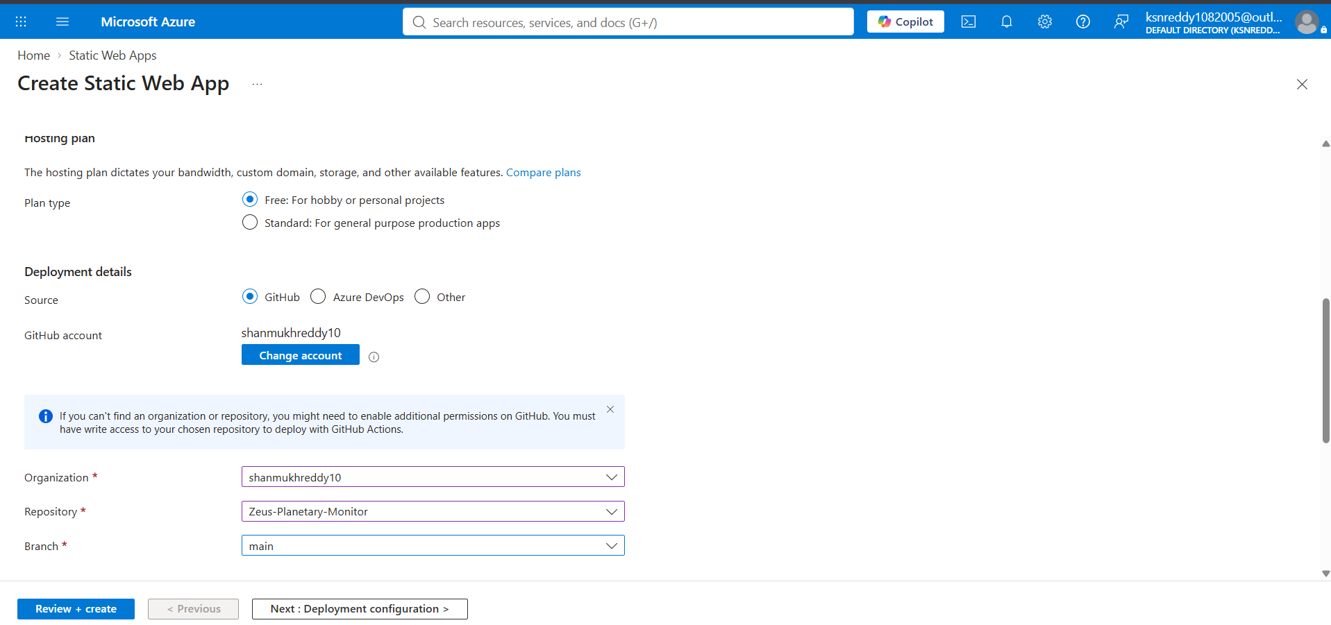
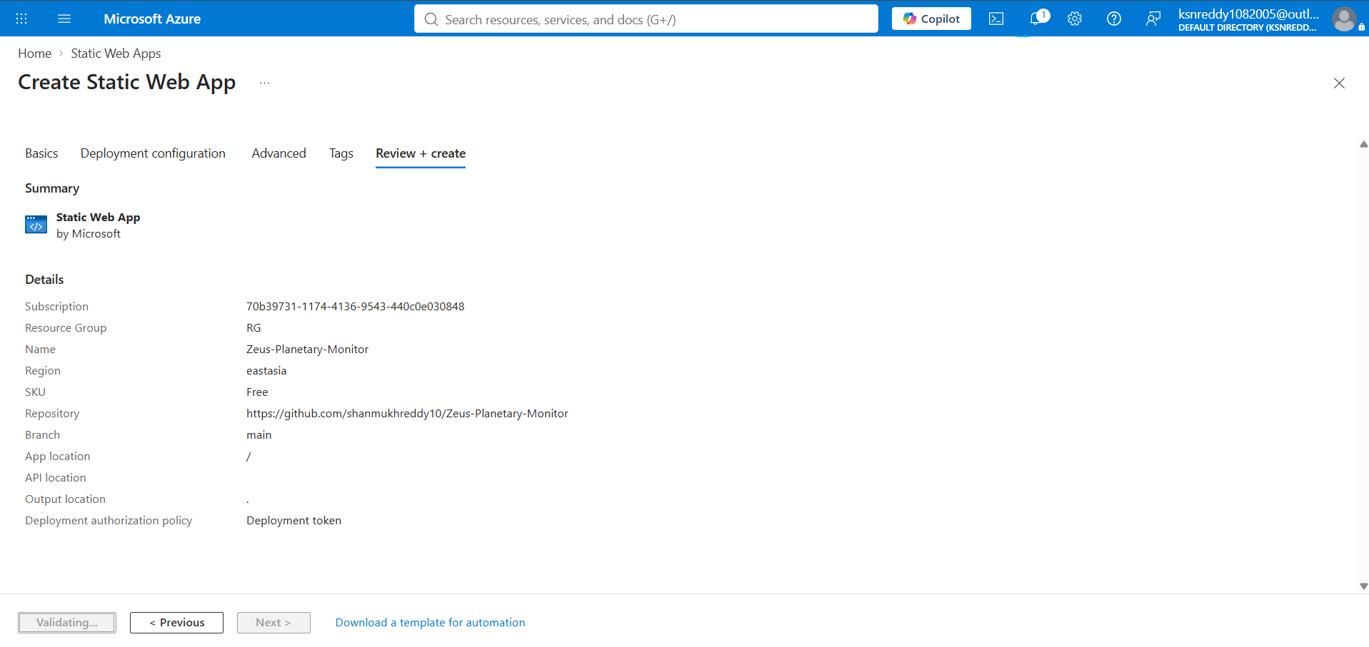
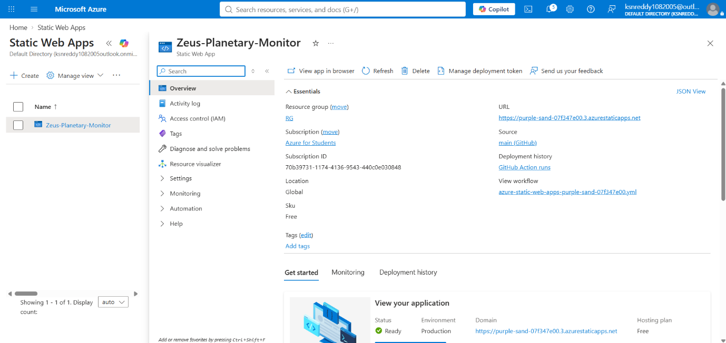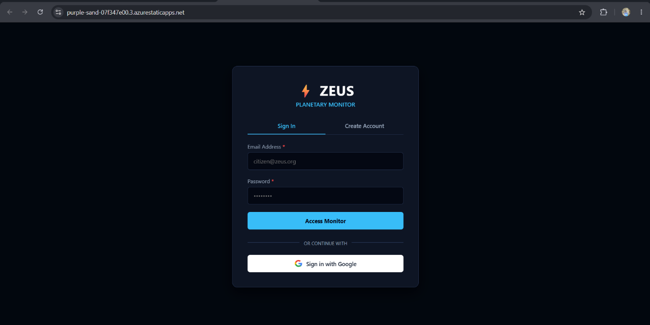

B. Azure DNS Zones (Custom Domain Routing)
- Manages domain name routing for the project.
- Configured a CNAME record (alerts) pointing directly to the Static Web App hostname.
- Ensures users can access the monitor through a clean custom domain.
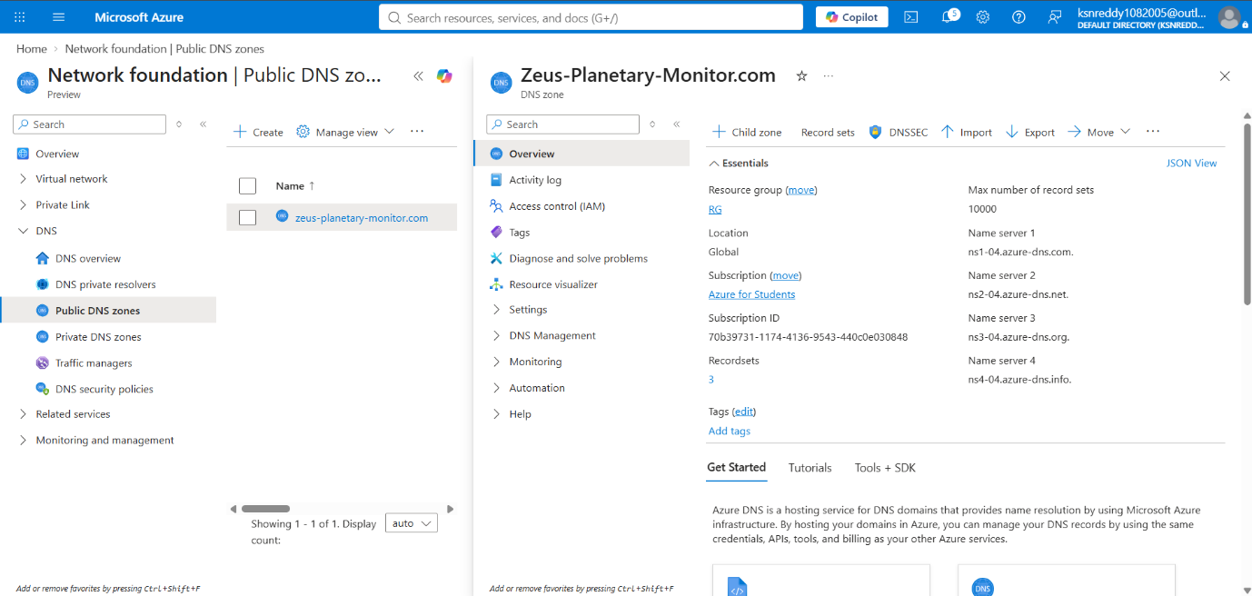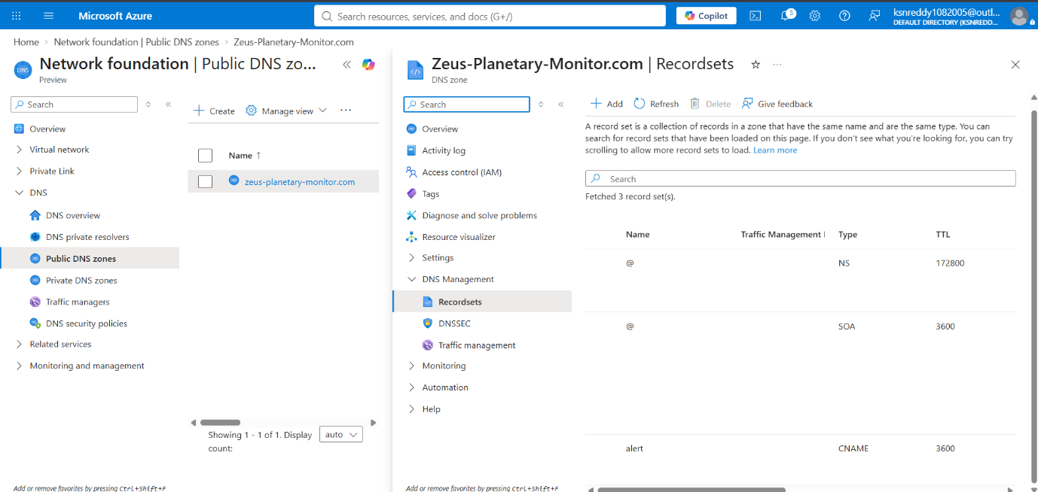

C. Azure Key Vault (Security & Secrets)
- Securely stores sensitive configuration data and API keys away from the frontend code.
- Uses Azure's security standards to ensure credentials are protected.
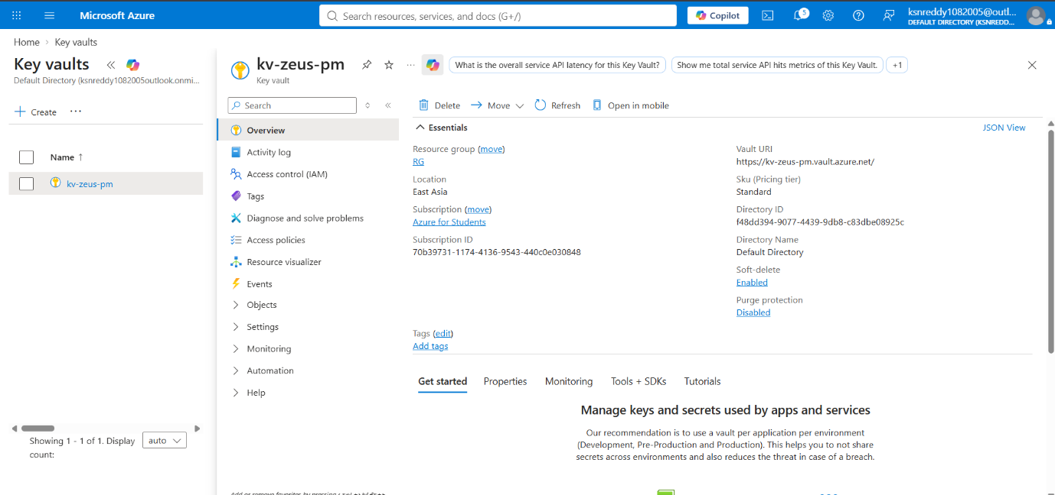
D. Azure Application Insights (Live Monitoring)
- Tracks how the website performs in real time.
- Monitors page load speeds, active user sessions, and API response times from USGS and NASA.
- Helps detect errors and crashes automatically.
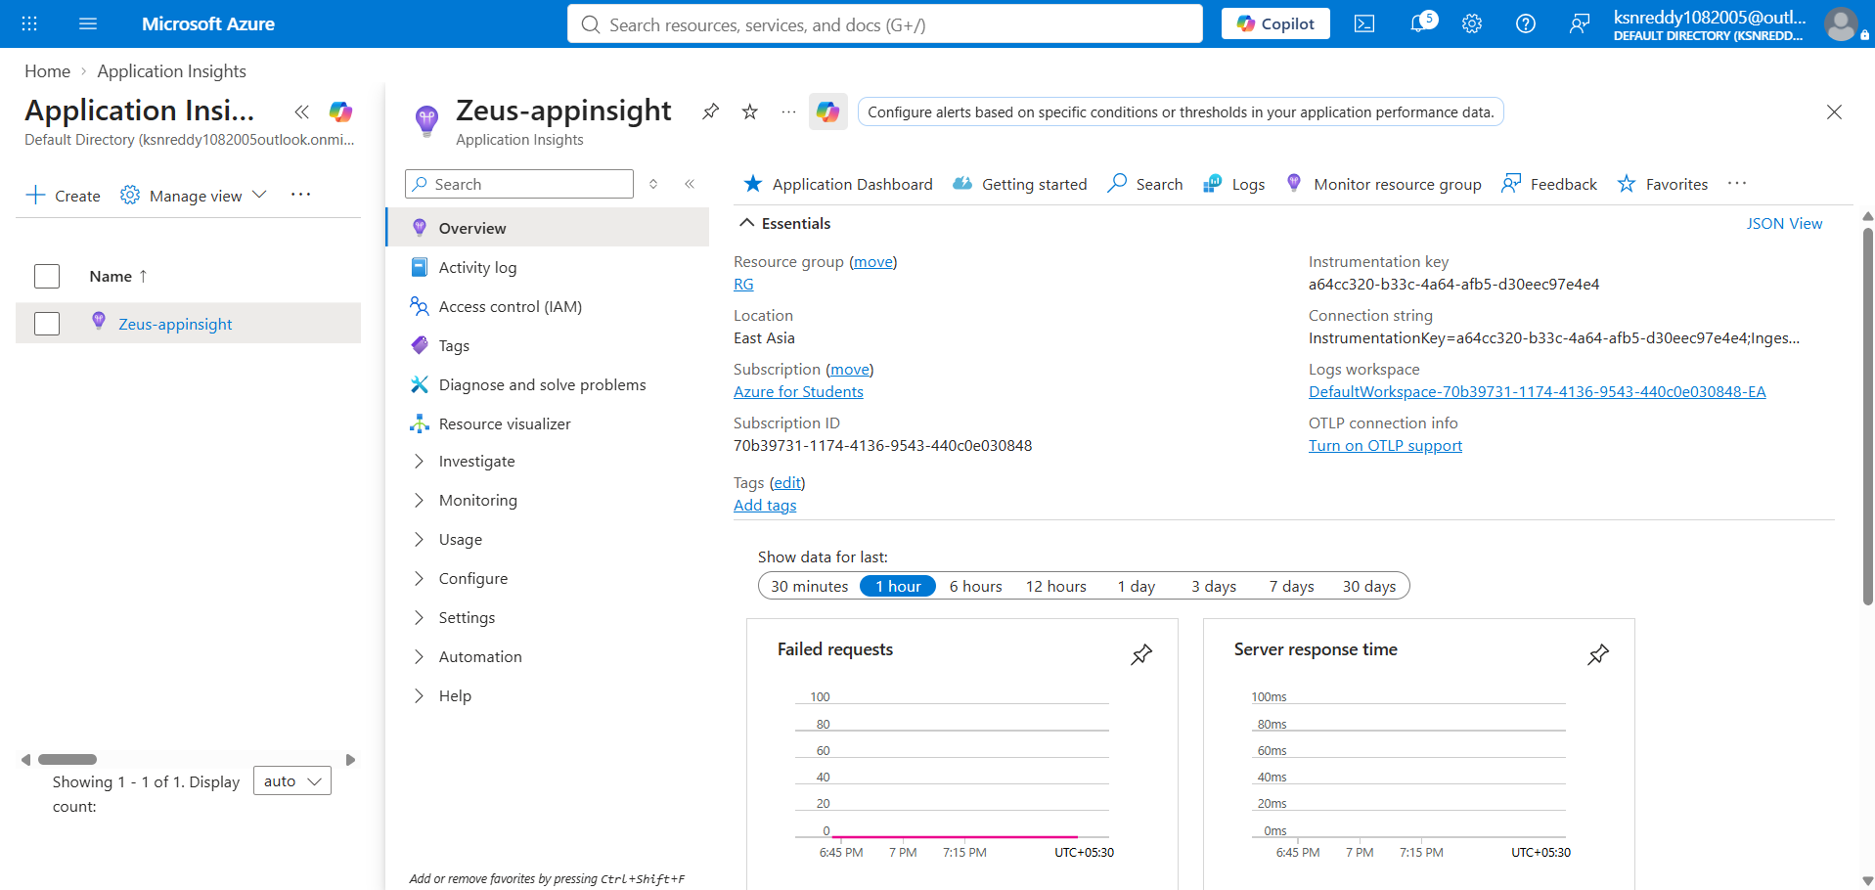

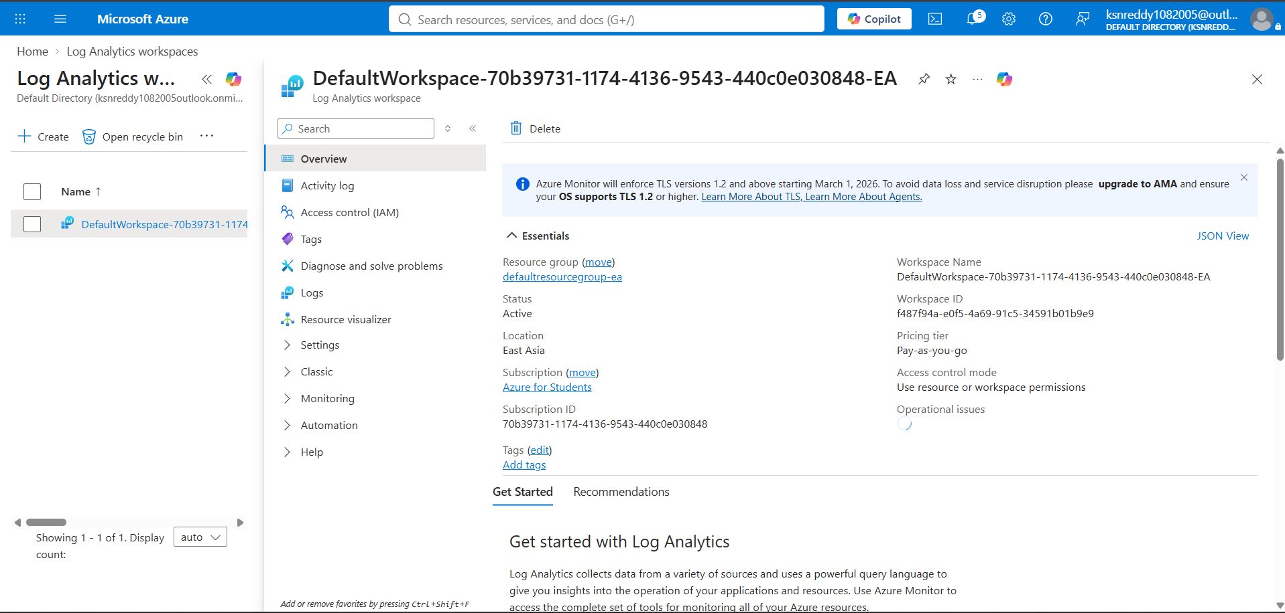
3. Resource Group Summary
All services were organized inside a single Azure Resource Group (RG) for simple management, monitoring, and cleanup.

